**Testing**

**Recap task:** Fill in some potential valid, invalid and extreme data for the user_guess variable in the hangman game (A version of the program is also supplied on the next page as a reminder)

|  |  |  |
| --- | --- | --- |
| **Testing Type** | **Description** | **How this might be used in the hangman program** |
| Black Box Testing | Carried out independently of the code used in the program.  It looks at the program specification and creates a set of test data that covers all the inputs, outputs and program functions | Valid:  Invalid:  Extreme: |
| White Box Testing | Tests are devised which test each path through the code at least once e.g using a Dry Run |  |
| Alpha Testing | Carried out by the software developer’s in-house team and by the user. It can reveal errors or omissions in the definition of the system requirements. The user may discover that the system does not do exactly what they wanted. |  |
| Beta Testing | The software is given to a number of potential users, who agree to use the software and report any faults |  |

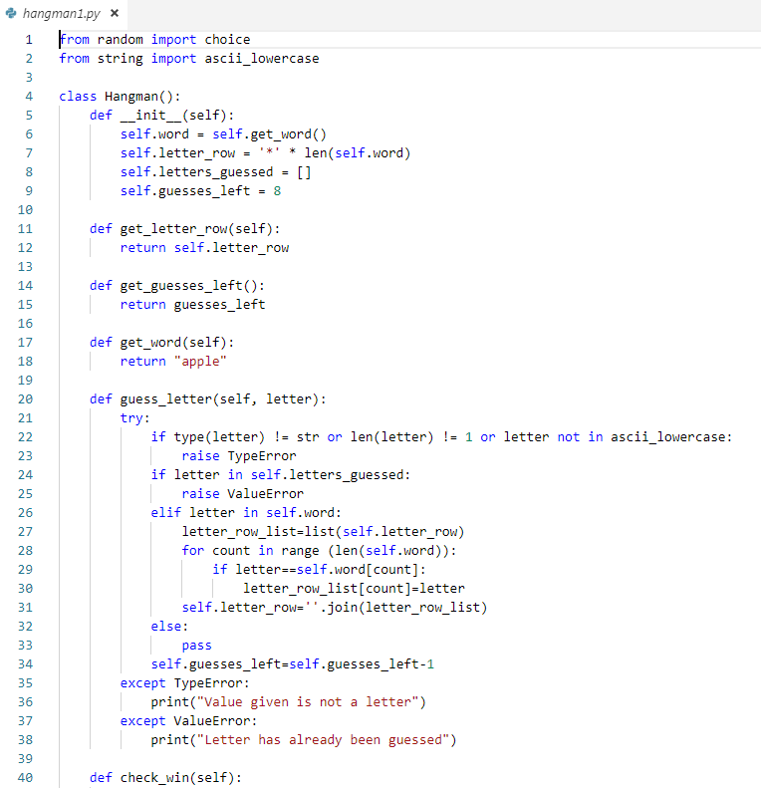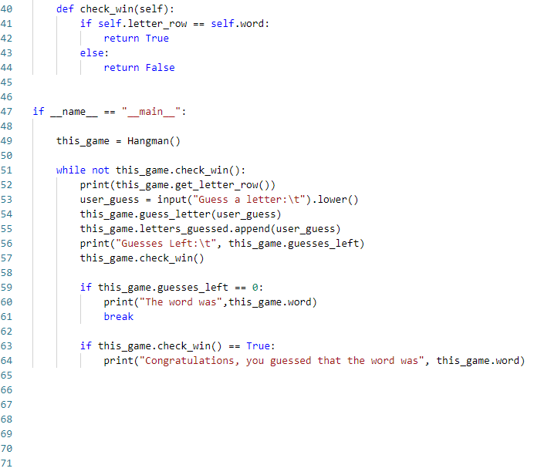

**White Box Testing task**

**Dry run (using a trace table)**

|  |  |  |  |  |
| --- | --- | --- | --- | --- |
| word | user_guess | guesses_left | letter_row | check_win() |
| apple | a | 8 | a**** | False |
| apple | # |  |  |  |
| apple | e |  |  |  |
| apple | p |  |  |  |
| apple | P |  |  |  |
| apple | l |  |  |  |
|  |  |  |  |  |

Main tasks:

1. Go to: <https://github.com/MrLauLearning/Hangman/>
2. Download hangman1.py, test_hangman1.py, words.txt and place them in a folder
3. In test_hangman1.py: Complete the test_guess_letter() method to test for all cases in the trace table above

Extension/Homework:

1. Download hangman2.py, test_hangman2.py and place them in the same folder as words.txt
2. Create a test called test_short_word() for the instance of the game called bob_test_game
3. Check if the number of asterisks in the letter_row is correct
4. Create a test to check if casting from upper case to lower case works and also check the game win state